Henkel
Functional Design Specification
SampleManager PhaseB

Document Reference | xxxx-FDS-SAMPLEMANAGER-B001
Version | 1.0
Last updated by | Zhenjuan.Zhang
Template Version | 1.0-0
Date
Status | Draft

chuxiaDocument Signoff
Name | Position | Company | Signature | Date

Table of Contents
Contents
1 Table of Contents 3
2 Introduction 5
2.1 This Document 5
2.1.1 Document overview 5
2.1.2 Disclaimer 5
2.1.3 Purpose 5
2.1.4 Scope 5
2.2 Synopsis 5
2.3 Definitions 5
2.4 References 6
3 Project Brief 7
3.1 Project Overview 7
3.1.1 Project detail 7
3.2 Functional Requirements 7
3.2.1 Sample Management 7

Version Management
Version | Description | Name | Date
1.0 | Created | Zhenjuan.Zhang

Introduction

This Document

Document overview
This document describes the system functionality of Phase B pilot stage covered in the Henkel QCLad System RTM User Requirements Analysis Report.

Disclaimer
The screenshots used below are screenshots generated during the system standard functions or system configuration, as well as customer sample screenshots, the final design may be different from the screenshots in the document, and the data on the screenshots is not the real data of the system, only for reference.

Purpose
This document is used to provide a detailed description of the functionality of the SampleManager system, identifying a description of the system functionality that meets the user's business needs as specified in the phase B pilot stage of User Requirements Analysis Report. The functionality of phase A, which is already deployed in the system, will not be described further

Scope
- Document the functional specifications of the laboratory management system based on the requirements described in the User Requirements Analysis Report.
- Determine the implementation of functionality in the system based on the needs described in the user needs analysis report

Synopsis
The core application functionality of the QCLad system is the laboratory sample process management functionality, including sample management, SAP interface, task scheduling, master data, reporting, architecture and security.;

Definitions
The following abbreviations and definitions are assumed throughout this document.
Term/  Abbreviation | Meaning | Description
FS | Function Specification | This Document
RMB | Right Mouse Button | Using RMB various Sample Manager options can be displayed
QCLAD | SampleManager | Software Name

References
The following references are made in this document.
Ref. No. | Reference | Description

Project Brief

Project Overview

Project detail
Implementation of SampleManager QCLad will streamline Sample Management, Reports, Dashboards, Instrument and Equipment management, Instrument interfacing and External application integration together with the associated data acquisition across Henkel’s labs.

Functional Requirements

Sample Management

Lab Testing Process Workflow

Business Scenarios
Generally, samples and tests will flow the process of workflow which is deployed during project stage phase A. In this document it will be referred to as the lab testing process and will be used in the lab as a base process for other subsequent workflows.

RTM Mapping

URS Ref. | Requirement | Type
4.1.5.1.1 | System shall be able to manage Standard RM test for Incoming workflow. （Standard RM） | Configuration
4.1.5.1.2 | System shall be able to manage Standard in process testing for semi finished and finished goods workflow. （without MES) | Configuration
4.1.5.1.3 | System shall be able to manage Standard finished goods outgoing test workflow. | Configuration
4.1.5.1.10 | System shall be able to manage Test for SCMS/NCMR /CCMS investigation workflow. | Configuration

Function Design
The lab testing process workflow defines the lifecycle of a sample from received status to authorization. See the flow chart below.
Samples and tests will be run according to this workflow if not otherwise specified.
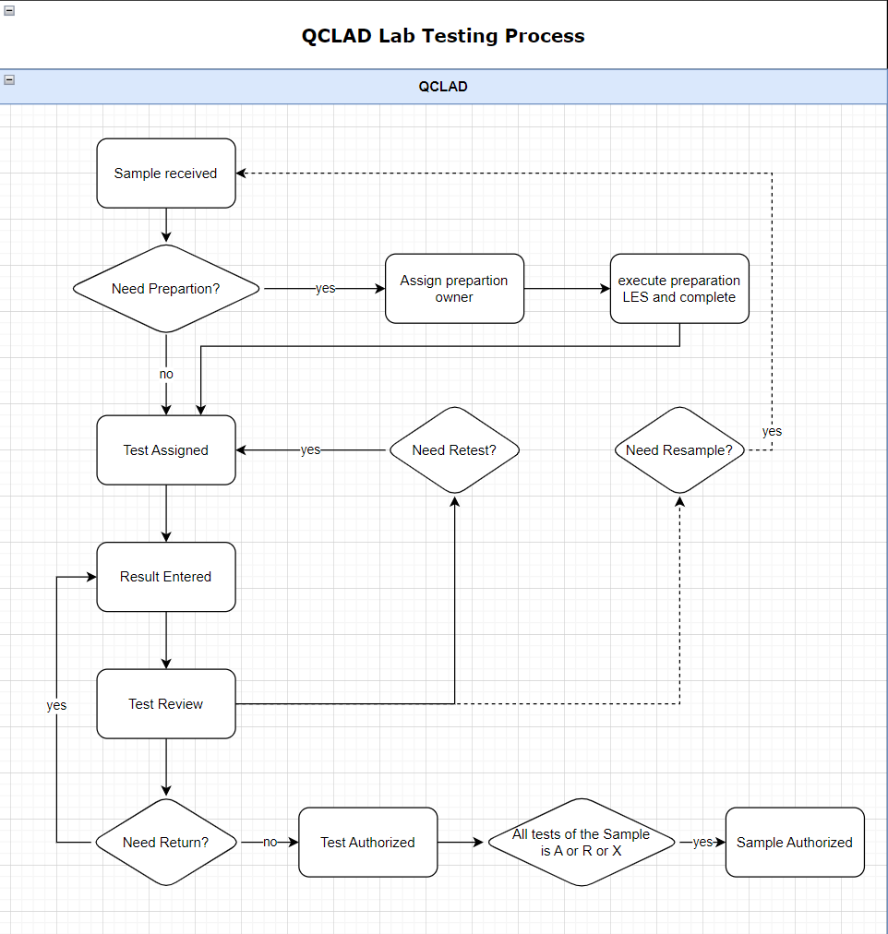

Truck Workflow

Business Scenarios
There are TRUCK samples that need to be created manually first, and then the sap inspection batch will be pushed. QCLAD needs to be able to return the results correctly.

RTM Mapping
URS Ref. | Requirement | Type
4.1.1.1.1 | System shall be able to login samples using configurable templates | Configuration
4.1.1.1.3 | System shall be able to create samples manually for standard testing. | Configuration

Function Design

Design Overviews
Users can create Tank samples and tests manually. QCLAD shall retrieve the results to SAP after inspection lot is received. (Based on RTM as above).
In the Sample management cabinet, samples and tests will be displayed in subfolders categorized by sample type. Truck sample will be grouped in sub folder IQC-TRUCK.

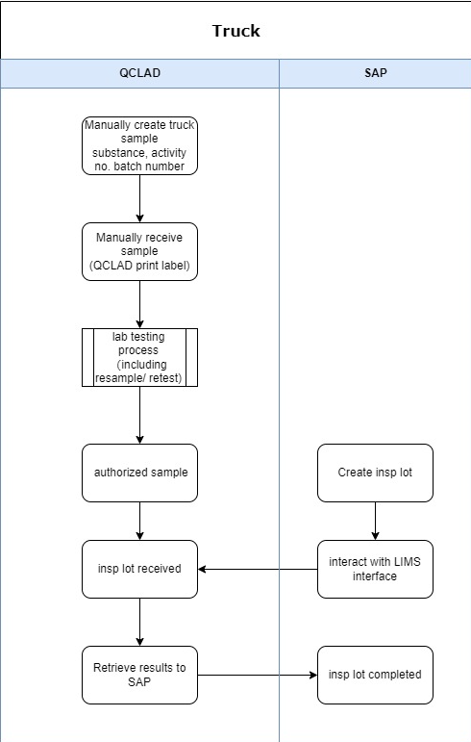

Process Design
Sample Login:
Truck Samples will be login by manually running sample login workflow Truck Sample by navigating to: Public folders-Sample Management-Create Sample.
The user needs to select the MLP and enter the batch number. QCLAD system will automatically fetch the IDH and activity number from the master data.
For truck material, creates the sample id by adding the entries.

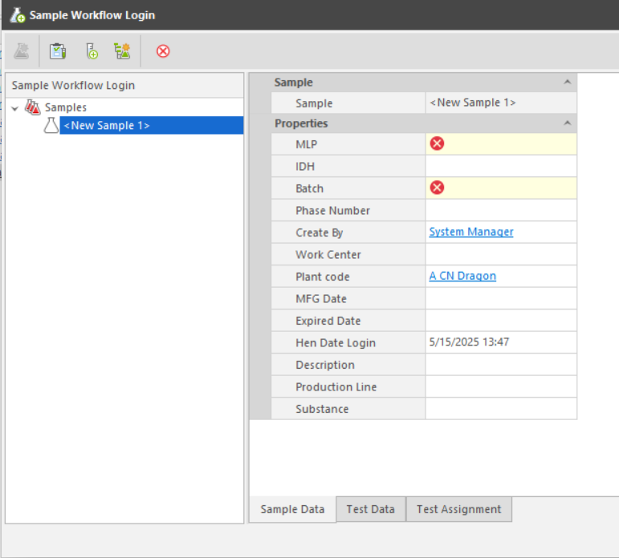
Properties in entity template clarification in LIMS:
No. | Properties | Type | Prompt Type | Description
1 | MLP | Identity | Mandatory | Links to MLP table
2 | Batch | Text | Mandatory | Batch id
3 | Plant code | Text | Optional | Links to Plant table
4 | Activity No | Numeric | Optional | Fetch from MLP
5 | Work Center | Text | Optional | Links to Work centre table
6 | Date Login | Date | Optional | Current date, modifiable.
7 | Create By | Operator | Optional | Current operator
8 | Description | Text | Optional | Descriptiom
9 | Substance | Identity | Optional | Fetch from MLP
10 | MFG Date | Date | Optional | Manufacture date
11 | Expired Date | Date | Optional | Expiration date
14 | Production Line | Identity | Optional | Fetch from MLP
Sample Receiving:
The user needs to find the specified sample from the New Sample Pending Receiving folder and right-click Receive Samples button to open the Sample Receiving window. After the sample is received, the sample label is automatically printed to the label printer in the corresponding work centre.
Sample Authorize:
When all tests for a sample are in the authorized or rejected status, the sample will automatically become authorized.
Authorized JIT samples will be listed in the Sample management-Authorized samples folder. System will highlight the JIT samples which has not received inspection lots from SAP by highlighting the background color in the Authorized samples folder.

Truck Samples are not automatically marked as waiting to be sent results to SAP when the sample is authorized, but need to wait for a response from the sap interface.

SAP interactive
Truck sample is created manually in QCLAD system.
When inspection lot created in SAP is pushed to QCLAD, interface would find the sample already existed in system and save the inspection lot number in the field ‘hen_inspection_lot’ and mark the field ‘hen_to_be_sent’ to true.

JIT Workflow

Business Scenarios
There are JIT samples that need to be created manually first. When all tests are all completed and reviewed, QCLAD will send the message which including sample decision information(A/R) to the MES. Then SAP will push the inspection lot and QCLAD needs to be able to return the results correctly.

RTM Mapping
URS Ref. | Requirement | Type
4.1.1.1.1 | System shall be able to login samples using configurable templates | Configuration
4.1.1.1.3 | System shall be able to create samples manually for standard testing. | Configuration

Function Design

Design Overviews
Users can create JIT samples and tests manually. QCLAD shall send the message to MES when sample is authorized and retrieve the results to SAP after inspection lot is received. (Based on RTM as above).
In the Sample management cabinet, samples and tests will be displayed in subfolders categorized by sample type. Truck sample will be grouped in sub folder IQC-JIT.

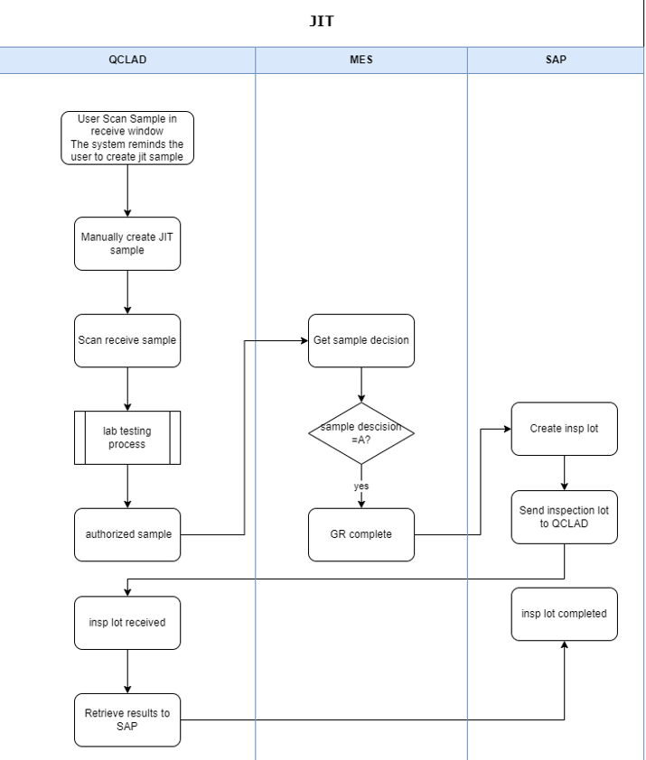

Process Design
Sample Login:
JIT Samples will be login by manually running sample login workflow JIT Sample by navigating to: Public folders-Sample Management-Create Sample
System shall remind user to create JIT sample when scanning receive the sample which has not yet been created in QCLAD
The user needs to select the MLP and enter the batch number. QCLAD system will automatically fetch the IDH and activity number from the master data.


Properties in entity template clarification in LIMS:
No. | Properties | Type | Prompt Type | Description
1 | MLP | Identity | Mandatory | Links to MLP table
2 | Batch | Text | Mandatory | Batch id
3 | Plant code | Text | Optional | Links to Plant table
4 | Activity No | Numeric | Mandatory | Activity number
5 | Work Center | Text | Optional | Links to Work centre table
6 | Date Login | Date | Optional | Current date, modifiable.
7 | Create By | Operator | Optional | Current operator
8 | Description | Text | Optional | Descriptiom
9 | Substance | Identity | Optional | Fetch from MLP
10 | MFG Date | Date | Optional | Manufacture date
11 | Expired Date | Date | Optional | Expiration date
14 | Production Line | Identity | Optional | Fetch from MLP
Sample Receiving:
Users can receive sample by scanning the MES label in sample receive window or manually finding the specified sample from the New Sample Pending Receiving folder.
After the sample is received successfully, the sample label is automatically printed to the label printer in the corresponding work centre.
The MES label should have a QR code that contains the information in the same format as phase A.
When a user scans to receive a JIT sample but the sample has not yet been created in QCLAD, system will remind the user in the scan window that the sample is a JIT sample.
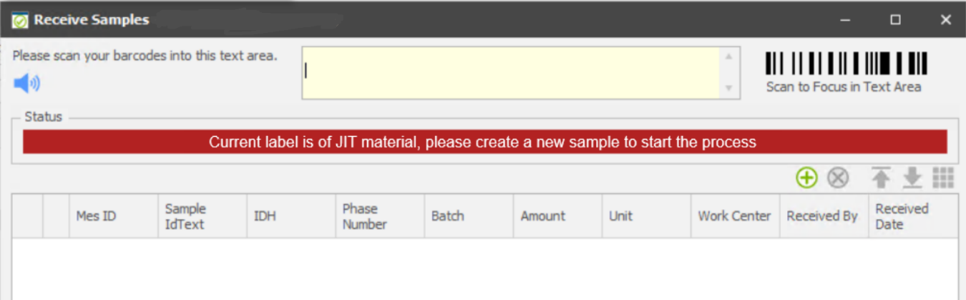
Sample Authorize:
When all tests for a sample are in the authorized or rejected status, the sample will automatically become authorized.
Authorized JIT samples will be listed in the Sample management-Authorized samples folder. System will highlight the JIT samples which has not received inspection lots from SAP by highlighting the background color in the Authorized samples folder.
JIT Samples are not automatically marked as waiting to be sent results to SAP when the sample is authorized but need to wait for a response from the sap interface.

SAP interactive
JIT sample is created manually in QCLAD system.
When inspection lot created in SAP is pushed to QCLAD, interface would find the sample already existed in system and mark it as waiting to be sent results.

MES interactive
When the sample is authorized, QCLAD determines the sample decision based on the on spec field on the sample table and sends a string to the MES interface.

MES Interface

Introduction
This document describes the system functionality for the integration between QCLAD (SampleManager) and MES (Manufacturing Execution System) as part of Phase B implementation.

Purpose
The purpose of this document is to provide detailed specifications for the MES-QCLAD integration, covering JIT (Just-In-Time) and IPQC (In-Process Quality Control) processes, including interface requirements, data mapping, and system logic.

RTM Mapping
URS Ref. | Requirement | Type
4.1.1.2.2 | System shall be able to trigger a resample from MES. | Customisation
4.1.1.17.3 | System shall be automatically login samples from MES. | Customisation
4.2.1.9.2 | System shall be able to support skill shall be sync with OSDP system if there is OSDP in plant.  Refer to 4.5.1.14 | Customisation
4.2.1.11.1 | System shall create tasks for samples based on specific frequency. | Customisation
4.5.1.12 | System shall push notify information(including resample and adjustment) to Henkel smart factory. | Interface
4.5.1.13 | System shall pull result information from Henkel smart factory. | Interface
4.5.1.14 | System shall support to upload result value from QCLAD to Henkel smart factory. | Interface
4.5.1.15 | System shall support to upload sample states from QCLAD to Henkel smart factory. | Interface
4.5.1.16 | System shall push/pull adjustment quantity information from/to Henkel smart factory. | Interface
4.5.1.17 | System shall pull operator skill information from Henkel Skill Matrix. | Interface
4.8.1.5.2 | System shall sync user’s testing skill from Henkel skill matrix tool. | Interface
4.8.2.3.2 | System shall sync user’s testing skill from Henkel skill matrix tool. | Interface

Scope
The scope of this document includes:
- JIT sample processing and result communication to MES
- IPQC sample processing and result communication to MES
- Production line information synchronization
- Interface specifications and data mapping
Note: The JIT and IPQC interfaces are the same interface, the JSON format is the same, only the content of the return will be different.

JIT Process Integration

Business Scenario
In the JIT process, samples are created manually in QCLAD before the inspection lot exists in SAP. After completing testing and authorization in QCLAD, the quality results must be sent to MES. When SAP later generates an inspection batch, QCLAD will match it to the existing sample.

Interface URL address
QCLAD will expose an API for MES to send JIT sample information and provide an API endpoint to receive results from QCLAD.

JIT Sample Info Receiving (QCLAD to MES)
- Vegam will expose one API (path will be provided later), to which data will be send from QCLAD once QC is done for JIT sample number.
- This API path and authentication credentials like client ID and client secret will be shared by Vegam. Using these credentials QCLAD need to get bearer token using Vegam oAuth API (path will be provided later).
- QCLAD need to send sample QC data as below JSON with authentication as bearer token which is generated in step 2.
Example request JSON:
{
"sampleType": "RECEIVING_SAMPLE",
"sampleLabelNumber": "0000216316",
"processOrder": null,
"batchNumber": "A1233",
"materialNumber": "383743",
"materialDescription": "Adeka Hardener EH 4070 S",
"plantCode": "0799",
"activityNumber": null,
"sampleApprovalRejectedTime": "YYYY-MM-DDTHH:mm:ssZ",
"operatorName": "4454", // To be discuused
"QCSampleResult": "Pass", //Pass or Reject
"isQCAdjustment": false,
"adjustMaterials": [],
"consesssionRelease": false,
"resampleRequired": false,
"remark": "",
"QCLabItemResultList ":[]
}

Example response JSON:
{
"MesSampleId": "0000574979",
"Status": 0,
"Message": ""
}

Error handling
ReturnCode | Description | Action By QCLAD
0001 | Success | No Action
0002 | API Authentication Error | Correct Authentication and Resend
0003 | Invalid Sample Number | Correct sample number and Resend
0004 | Invalid date time format | Correct the data and Resend
0005 | Invalid JSON | MES Will take care further process

Field Mapping
No. | MES Field | Description | QCLAD Field Mapping
 | sampleType | sample Type | sample.sampletype
 | sampleLabelNumber | Unique ID for the sample | sample.HenMesId
 | processOrder | SAP Process Order | Sample.HenProcessOrder
 | batchNumber | SAP Batch Number | sample.BatchName
 | materialNumber | SAP Material Code | sample.Substance.hencode
 | materialDescription | Description of material | sample.Substance.Name
 | plantCode | SAP Plant | sample.HenPlantcode
 | activityNumber | SAP phase in the routing | sample.HenPhraseNumber
 | sampleApprovalRejectedTime | Date and time sample was approved/rejected | sample.DateAuthorised
 | operatorName | Operator who approved sample | sample.Authoriser
 | QCSampleResult | Approved or Rejected | sample.Status and sample.OnSpec
 | isQCAdjustment | is QC Adjustment | NA
 | adjustMaterials | The material information that needs to be adjusted can be zero or more. | NA
 | consesssionRelease | consesssion Release | NA
 | resampleRequired | If the phase required re sample | NA
 | remark | Comments | NA
 | QCLabItemResultList |  | NA

System Logic
- When a JIT sample is authorized in QCLAD, the system sets hen_MES_to_be_sent to true
- A background task (HenSendJITResultToMESTask) runs every 5 minutes
- The task retrieves all JIT samples with hen_MES_to_be_sent=true and hen_MES_Has_sent=false
- For each sample, QCLAD calls the MES interface to send sample information.
- After successful transmission, hen_MES_Has_sent is set to true
- In QCLAD interface log will have separate MES interface log for investigations.

IPQC Process Integration

Business Scenario
For IPQC samples, QCLAD will send test results to MES after sample authorization. This includes passing results, failed results with adjustment requirements, or resample requests.

Interface URL address
QCLAD will expose an API for MES to send IPQC sample information and provide an API endpoint to receive results from QCLAD.

Interface requirements
- After completion of IPQC testing, QCLAD will push the results with usage decision, MIC results, MES Sample ID and adjustment material, quantity (in case there is an adjustment)
- In QCLAD, there should be an option to select the usage to be sent to MES
  - In case all MICs are passed, QCLAD will push “Accept” code.
  - In case one or MICs fail, QCLAD should need to send the following based on QC selection
      - Rejected with adjustment. Need to add a flag whether it is QC adjustment or manufacturing adjustment. If it is QC adjustment, will populate adjustment material, adjustment quantity, adjustment quantity UOM, storage location and free text with comments of QC. MES has to create a new adjustment phase with all details provided by QC. In case there is no stock, MES has to wait in this phase till stock arrives and then continue to adjustment phase.
If it is not done by QC, need to get the details of adjustment from manufacturing.
      - Rejected with resample. QCLAD need to give an option to write instruction note for this scenario. MES need to send a new sample without any adjustment. QCLAD will provide a popup message for user to resample. The user in QCLAD create resample for virtual sample id and wait for MES label to receive it.
      - Rejected as Off-spec. On receiving this, MES has to discontinue from going to next phase or if it is last phase should not go with packaging
Accepted with Concession- On receiving this MES has to continue the next phase. If it is last phase should continue with packaging.

IPQC Sample Info Receiving (QCLAD to MES)
- Vegam/DCS will expose one API (path will be provided later, same IPQC info receiving API will be used), to which data will be send from QCLAD once QC is done for IPQC sample number.
- This API path and authentication credentials like client ID and client secret will be shared by Vegam (these will be same as IPQC receiving info).
Using these credentials QCLAD need to get bearer token using Vegam oAuth API (path will be provided later).
- QCLAD need to send sample QC data as below JSON with authentication as bearer token which is generated in step 2.
Example request JSON:
{
"SampleType": "IPQC",
"SampleLabelNumber": "371584",
"ProcessOrder": "001004172754",
"BatchNumber": "0007447212",
"MaterialNumber": "1392015",
"MaterialDescription": "Liquid Detergent Lavender",
"PlantCode": "0799",
"ActivityNumber": "0023",
"AampleApprovalRejectedTime": "YYYY-MM-DD HH:mm:ss", //plant time zone
"OperatorName": "John Doe",
"QCSampleResult": "Pass", //Pass or Reject
"isQCAdjustment": True, [True/False]
"AdjustMaterials": [
{
"MaterialNumber": "123456",
"BatchNumber": "BT01XZSH",
"Quantity": 10,
"UOM": "KG",
"StorageLocation" : "ST01"
}
],
"ConsesssionRelease": false, //true or false
"ResampleRequired": false, //true or false
"Remark": "",// commet based on sample level
"QCLabItemResultList":[{
"InspectionLot":"1234567890",
“InspectionCharNumber":"0020",
"MasterInspectionCharacteristics":"00000069",
"InspectionCharacteristicsText":"TENSILE LAP-SHEAR STRENGTH",
"InspectionMethod":"00595101",
"InspectionMethodText":"Shear Strength-Block Specimens",
"LowerSpecLimit":254.5,
"UpperSpecLimit":290.6,
"DecimalPlace":1,
"MeasureUnit":"N/mm2",
"ResultRecordType":"N", //can be N-Numeric or O-Options
"Result":"275.7", //if result is type is N then decimal result as string else pass/fail
"Comments":""
}
]
}

Example response JSON:
{
"MesSampleId": "0000574979",
"Status": 0,
"Message": ""
}

Error handling
ReturnCode | Description | Action By QCLAD
0001 | Success | No Action
0002 | API Authentication Error | Correct Authentication and Resend
0003 | Invalid Sample Number | Correct sample number and Resend
0004 | Invalid date time format | Correct the data and Resend
0005 | Invalid JSON | MES Will take care further process

Field Mapping

No. | MES Field | Description | QCLAD Field Mapping
 | sampleType | sample Type | sample.HenInspectionCategory
 | sampleLabelNumber | Unique ID for the sample | sample.HenMesId
 | processOrder | SAP Process Order | Sample.HenProcessOrder
 | batchNumber | SAP Batch Number | sample.BatchName
 | materialNumber | SAP Material Code | sample.Substance.Identity
 | materialDescription | Description of material | sample.Substance.Name
 | plantCode | SAP Plant | sample.HenPlant
 | activityNumber | SAP phase in the routing | sample.HenPhraseNumber
 | sampleApprovalRejectedTime | Date and time sample was approved/rejected | sample.DateAuthorised
 | operatorName | Operator who approved sample | sample.Authoriser
 | QCSampleResult | Approved or Rejected | sample.Status and sample.OnSpec
 | isQCAdjustment | is QC Adjustment | NA
 | adjustMaterials | The material information that needs to be adjusted can be zero or more. | NA
 | materialNumber | Material used for any adjustment during sampling | NA
 | batchNumber | bacth number of adjustment material | NA
 | quantity | Amount of material sampled or adjusted | NA
 | uom | unit | NA
 | storageLocation | storage Location | NA
 | consesssionRelease | consesssion Release | NA
 | resampleRequired | If the phase required re sample | NA
 | remark | Comments | NA
 | QCLabItemResultList |  | NA
 | InspectionLot | Lot number for IPQC | Hen_inspectionlot
 | inspectionCharNumber | Order no | test.hen_orderno
 | masterInspectionCharacteristics | MIC_code | test.hen_mic_code
 | inspectionCharacteristicsText | short_text | test.hen_short_text
 | inspectionMethod | Test Method | Test.TestMethod
 | inspectionMethodText | Test Method Name | Test.analysis.name
 | lowerSpecLimit | lower Spec Limit | MLP_VALUES.MIN_LIMIT
 | upperSpecLimit | upper Spec Limit | MLP_VALUES.MAX_LIMIT
 | decimalPlace | PLACES | result.places
 | measureUnit | unit | result.Units
 | resultRecordType | result Type | result.resultType
 | InspectionResult | result value | result_raw_result
 | codeText | OnSpec | result.hen_on_spec

System Logic
- A background task (HenSendResultToMESTask) runs every 5 minutes
- The task retrieves all IPQC samples with hen_MES_to_be_sent=true and hen_MES_Has_sent=false
- For each sample:
- If passed: Send decision "Accept" without adjustment information
- If failed: Four options as below:
- Send decision "Accept with concession " without adjustment information
- Send decision "Reject with adjustment" with adjustment information
- Send decision "Reject with resample" without adjustment information
- Send decision "Reject with off spec" without adjustment information
Details: Refer to prototype as below:
Path: Sample management cabinetàAuthorized sample folderàIPQC subfolder.
Under authorized sample folder, only for IPQC sample with “usage done” is ‘No’ will highlight in pink to reminder user the sample without decisions.
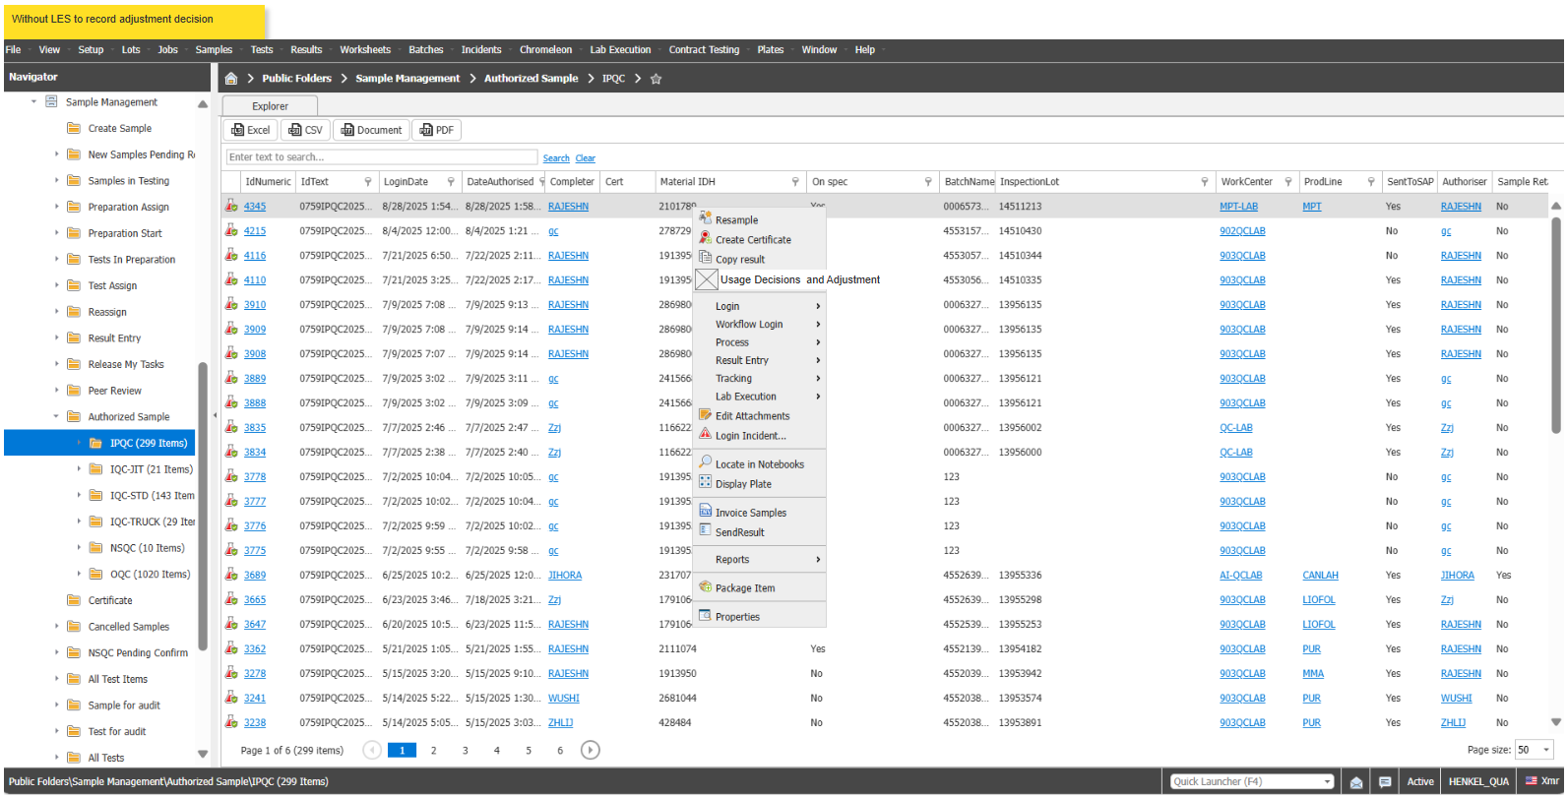
Notes: the “Usage decision and adjustment” button (button name can be customized by user if needed) will show up when the sample type is ‘IPQC’ and Usage decision filed is ‘No’.
Step1: right click “Usage Decisions and adjustment” Master Menu on test item. Will pop up default windows as below:
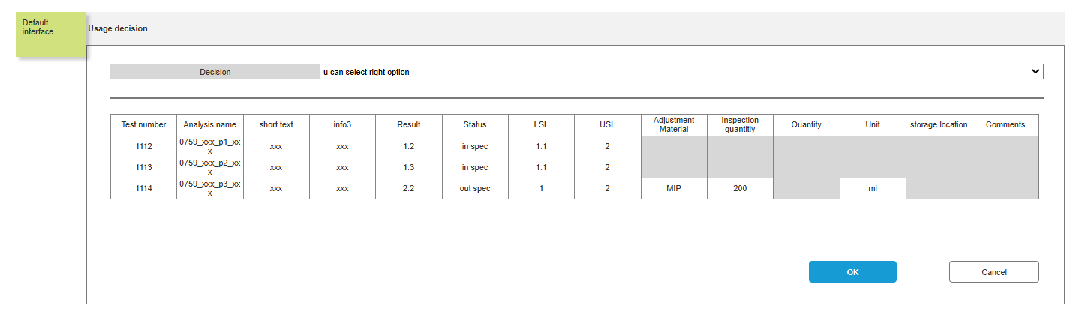
Note: This test item information form is for display purposes only. Users cannot modify it; they may only select “Reject with adjustment” by the options.
This form will be shown under all options for the user's reference, except for 'Reject with Adjustment' and Click 'Done by QC', as this option will only be shown for out-of-spec test items.
User select each option will show up as below:
Option1: user select “reject with adjustment” without clicking “done by qc” as below:
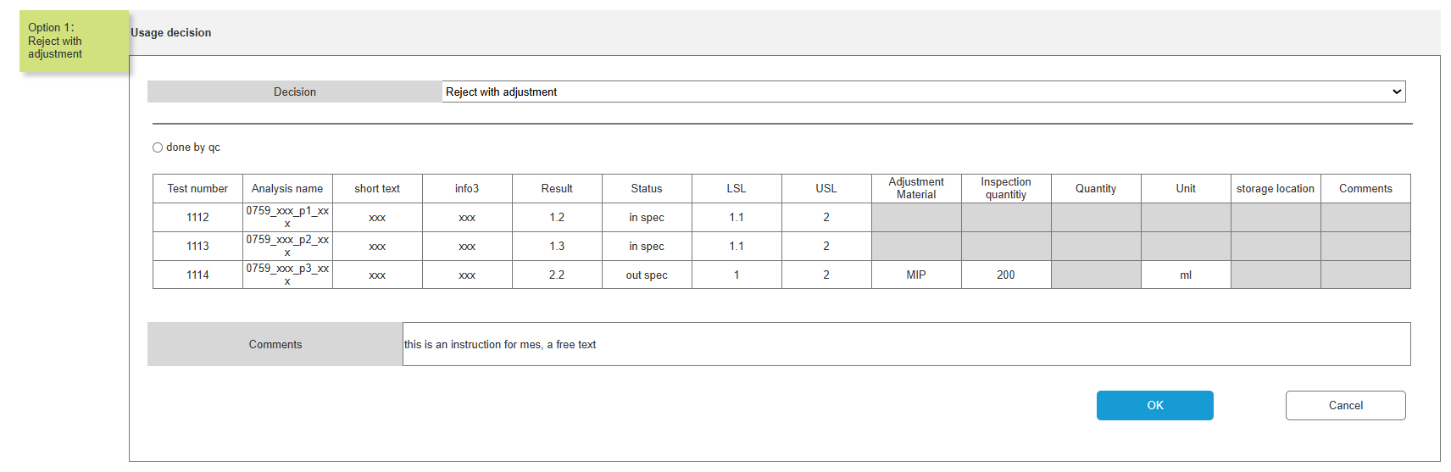
Option1: user select “reject with adjustment” with clicking “done by qc” as below:
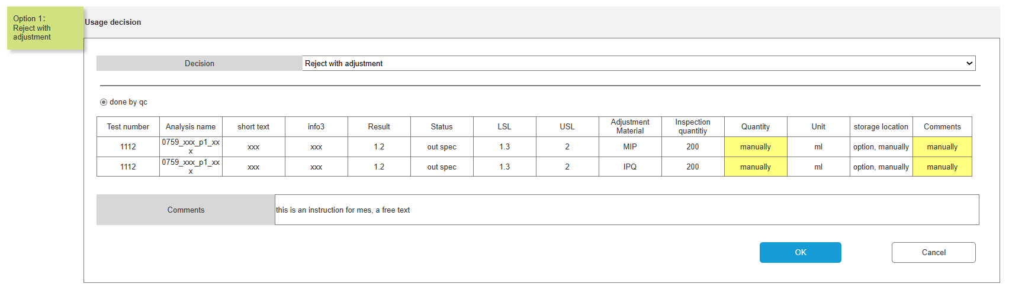
Users can input or select values for the three fields: “Quantity,” “Storage Location,” and “Comments.”
Fields description:
Field Name | Example Value | Mandatory? | Input Method
Test number | 1112 | Yes | Auto
Analysis name | 0759_xxx_p1_xxx | Yes | Auto
short text | xxx | Yes | Auto
info3 | xxx | No | Auto
Result | 1.2 | Yes | Auto
Status | out spec | Yes | Auto
LSL | 1.3 | Yes | Auto
USL | 2 | Yes | Auto
Adjustment Material | MIP | Yes | Auto capture from adjustment table
Inspection quantity | 200 | Yes | Auto
Quantity | manually | Yes | Manual
Unit | ml | Yes | Auto
storage location | option, manually | No | Auto capture from adjustment table
Comments | manually | Yes | Manual
These fields are all captured from master data “Adjustment table”.
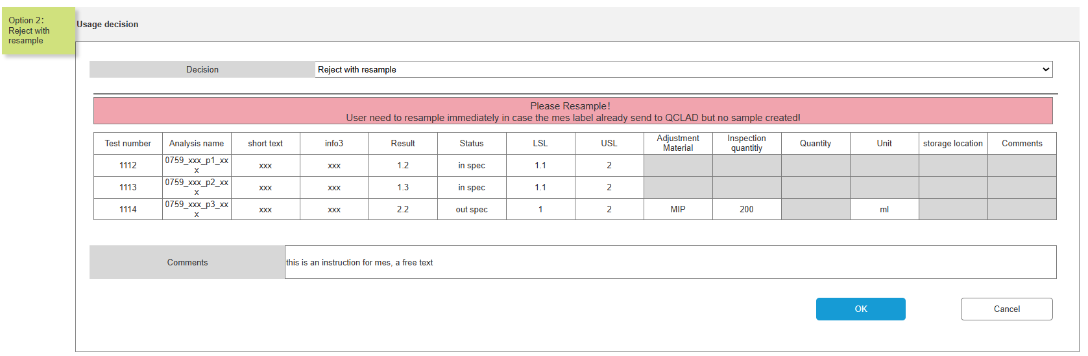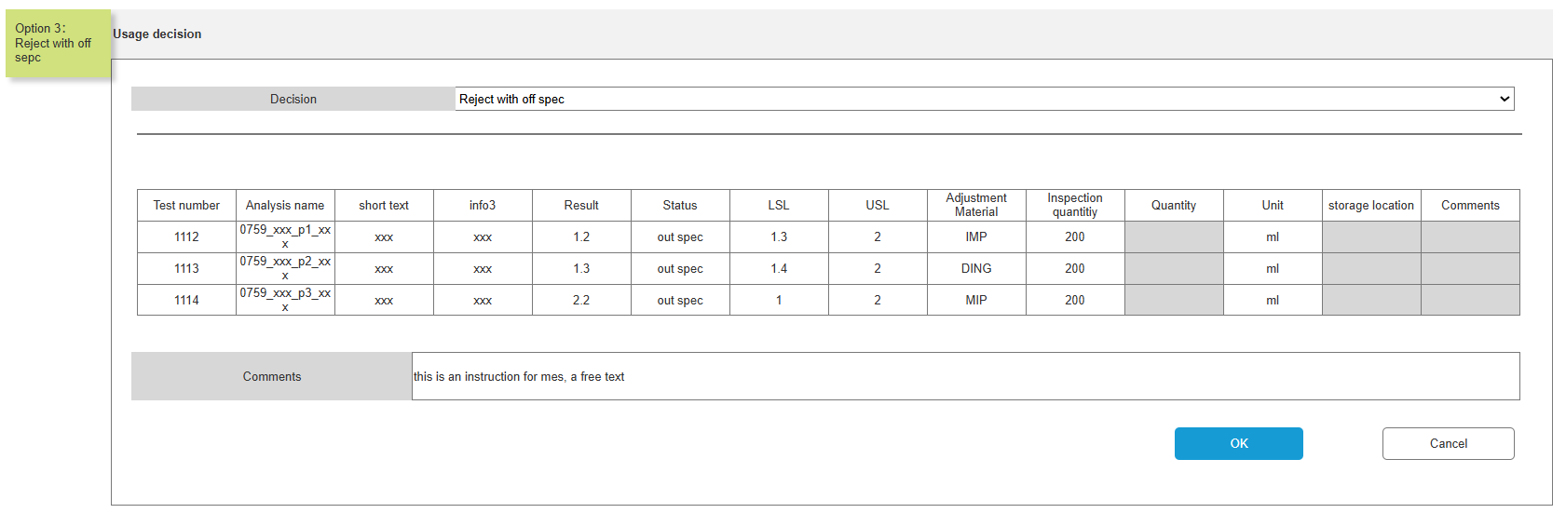
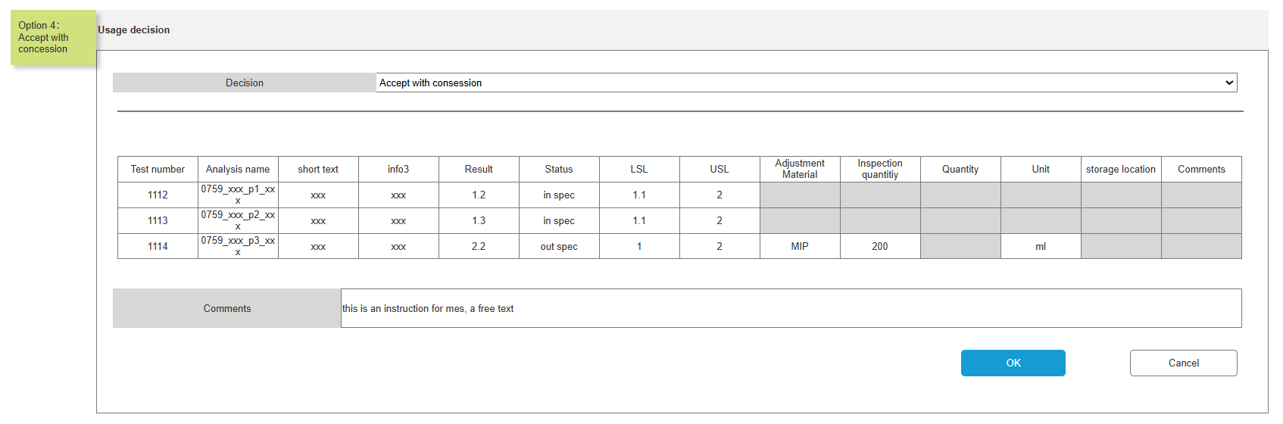
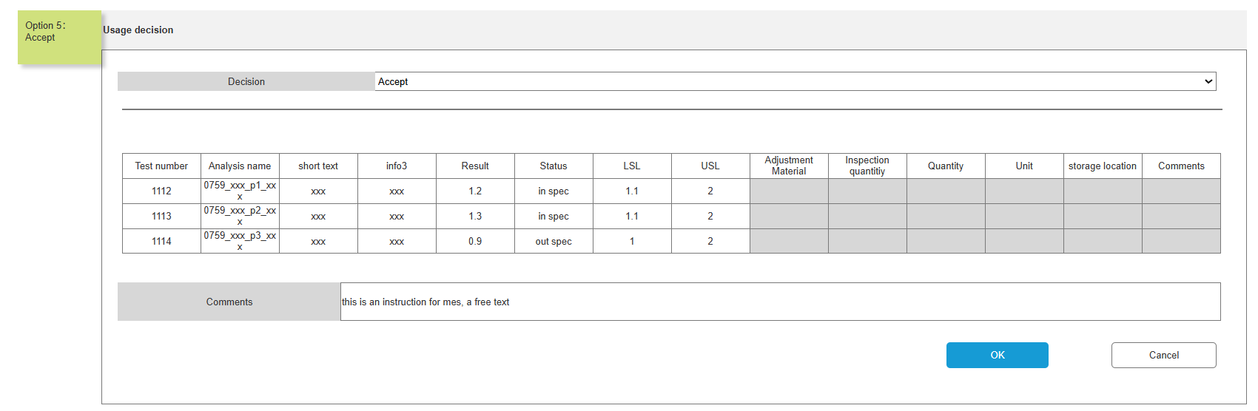
Step2: If users select the usage decision and enter the mandatory information, then click  button. Will pop up confirmation check window as below.
If users click 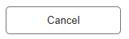button, the “Usage decision”window will cancel and the inforamtion won’t store.
For option 1: “Reject with Adjustemnt”
will have two window as different selection on “done by qc”
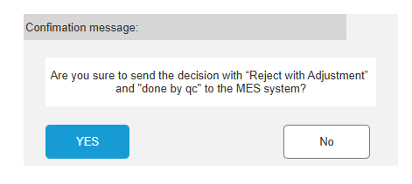
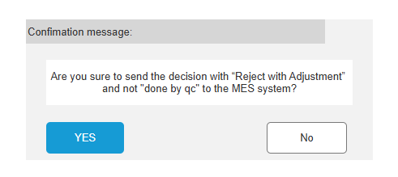
For option 2: “Reject with Resample”
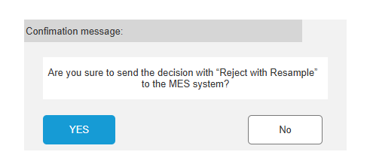
For option 3: “Reject with off spec”
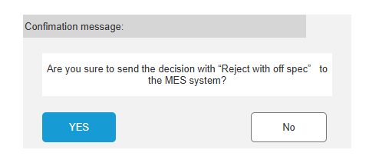
For option 4: “Accept with concession”
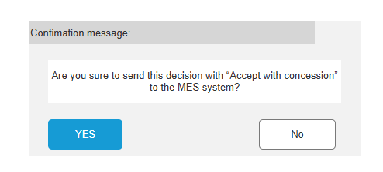
For option 5: “Accept”
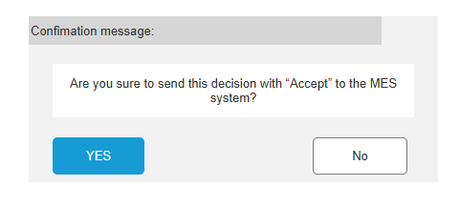
Step3: If users click  button. The “Usage done”field will change to YES and Hen_to_be_sent is set to TRUE. Meantime higlight in pink will disapper.
If users click 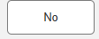 button. The fields and highlight won’t change.
- Once the user has finished making their usage decisions, the “usage done” field on sample table will change to 'Yes' and Hen_to_be_sent is set to TRUE, the adjustment information will be stored into the json file.
- Add a new field to the sample table to indicate which system the sample was sent to, enabling the plant team to check whether the results have been pushed to the MES or DCS.
- After successful transmission, Hen_MES_Has_sent is set to TRUE.
- Adjustment master data maintenance and information entry
Add a new adjustment table: Hen_adjustment_table:
Example:
Fields description:
Field | Is it a primary key | Field type | Mandatory | Description
MLP | Y | Links Mlp_header table | Y
IDH |  | Text |  | sample IDH  Automatically imported from MLP
Analysis | Y | Links versioned_Analysis table | Y
Analysis Name |  | text |  | Automatically imported from Analysis
TestMetthod |  | text |  | Automatically imported from Analysis
Above_standard | Y | Links Phrase | Y | Above standard or below standard  Phrase options ：Above、Below
Adjustment_Material | Y | Links substance table | Y | adjustment IDH
Plant |  | Links hen_Plant table | Y
WorkCenter |  | Links hen_WorkCenter table
storage location |  | Links hen_Plant_location table
Product Line |  | Links hen_Product_line table
modify_on |  | Date |  | Automatically entered by the system
modify_by |  | Links personnel table |  | Automatically entered by the system
Group |  | Links group_header table |  | Automatically import Plant's Group

- Production line master data configuration:
- Configure whether IPQC needs feedback
- Configure if need to send to MES or DCS.
- Plant master data configuration:
- Configure MES and DCS interface addresses
Note: The IPQC needs to be passed back to both the MES and the DCS. However, the JSON format of the request and response for the MES and DCS interfaces remains the same. The MES is authenticated by a token, while the DCS interface uses basic authentication with a username and password.
- Plant Storage Location data distribution via SAP plant interface and storage
- Add batch quantity and unit fields to SAP Inspection lot interface
- JIT & IPQC result feedback interface calls (requires MES interface to first provide authentication and interface information)
Sub-tasks:
- Adjustment information entry
- JIT & IPQC result feedback interface calls (requires MES interface to first provide authentication and interface information)
- The system will give a pop-up with "Yes" or "No" to warn users whether you really need to do this or not. This is to prevent the accidental and this can create issues in supply chain.
- The system will only give one decision to MES based on sample level.

Production Line Information Synchronization

Business Scenario
In QCLAD, the production line information needs to be synchronized with MES data. QCLAD will request this information from MES Label.

Requirements
- MES label will provide the production line information, QCLAD will capture the information and store in substance level. If no change, QCLAD will keep it as it is.

System Logic
- For each MES label with production line information, QCLAD will retrieve the information and update to substance template.

API detail

API Authentication Mechanism
All APIs will use Owin OAuth 2.0 for Authentication. We are generating access token using the OAuth2.0 framework.
Access Token Request
When the user authorizes the application, the access token request will be sent to the authorization module within the server. The module will generate an access token for the client which is only valid for 30 minutes. All APIs are to be accessed using this access token
# | API Name | Description | Hosted On | Type
1 | GetAccessToken | Get access token for accessing the required API | SmartFactory Solution | Pull
The API specifications is elaborated in the sections below.
GetAccessToken
The API provides access token for accessing SmartFactory Solution API. The API will be called by Rohlig before accessing any API of SmartFactory Solution. The API returns access token information.
Web service URL to access test server:
https://sfs-ap-test.henkelgroup.net/VegamOauthServer/GetAccessToken
Web service URL to access production server:
https://ap-hipas.henkelgroup.net/VegamOauthServer/GetAccessToken
Web service Type: POST
Web service input parameters:
Parameter Name | Description | DateType | Is Mandatory
client_id | Required for access token generation. Details will be provided by SmartFactory solution. | VARCHAR | Yes
client_secret | Required for access token generation. Details will be provided by SmartFactory solution. | VARCHAR | Yes
grant_type | Required for access token generation. Must be set to the value client_credentials | VARCHAR | Yes

By default, these parameters must be x-www-form-urlencoded and specified in the request body (as shown in the sample below)

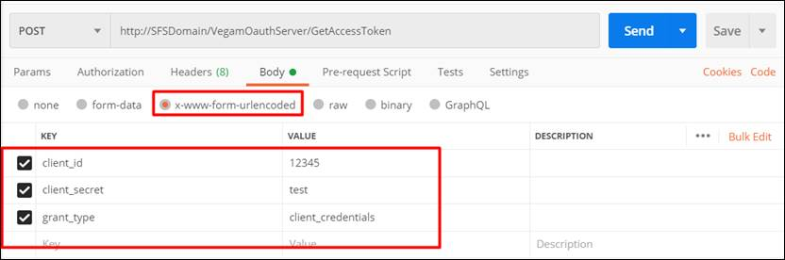

Web service output:
Output will be JSON response with access token as one of the parameters which need to be used for accessing AMS solution API.

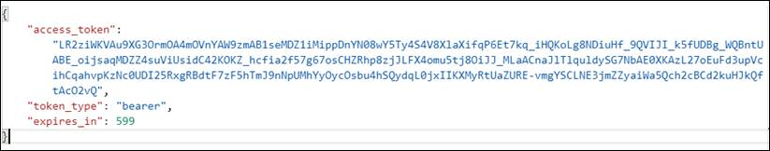

In case of error below information with ErrorCode will be displayed
ErrorCode Information:
Error Code | Description
0001 | Invalid client info
0002 | Error while processing request
{
"error": "",
"error_description": ""
}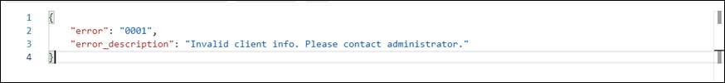

API Specifications
API is required to be developed to successfully integrate QCLAD with Vegam SmartFactory solution. API will need to be developed and exposed by Vegam SmartFactory solution, as explained in the table below.
# | API Name | Description | Hosted On | Type
2 | UpdateSampleQualityInfo | Insert / Update Sample label quality details into SmartFactory solution | Vegam Domain | Push

The API specifications is elaborated in the below sections.
UpdateSampleQualityInfo
API will accept agreed JSON structure, details are as below.
Web service URL to access vegam test server:
https://sfs-ap-test.henkelgroup.net/ VegamOauthServer/api/data/UpdateSampleQualityInfo
Web service URL to access vegam production server:
https://ap-hipas.henkelgroup.net/ VegamOauthServer/api/data/UpdateSampleQualityInfo
Web service Type: POST
Web service input parameters for IPQC:
{
"SampleType": "IPQC",
"SampleLabelNumber": "371584",
"ProcessOrder": "001004172754",
"BatchNumber": "0007447212",
"MaterialNumber": "1392015",
"MaterialDescription": "Liquid Detergent Lavender",
"PlantCode": "0799",
"ActivityNumber": "0023",
"AampleApprovalRejectedTime": "YYYY-MM-DD HH:mm:ss", //plant time zone
"OperatorName": "John Doe",
"QCSampleResult": "Pass", //Pass or Reject
"AdjustMaterials": [
{
"MaterialNumber": "123456",
"BatchNumber": "BT01XZSH",
"Quantity": 10,
"UOM": "KG",
"StorageLocation" : "ST01"
}
],
"ConsesssionRelease": false, //true or false
"ResampleRequired": false, //true or false
"Remark": "",
"QCLabItemResultList":[{
"InspectionLot":"1234567890",
“InspectionCharNumber":"0020",
"MasterInspectionCharacteristics":"00000069",
"InspectionCharacteristicsText":"TENSILE LAP-SHEAR STRENGTH",
"InspectionMethod":"00595101",
"InspectionMethodText":"Shear Strength-Block Specimens",
"LowerSpecLimit":254.5,
"UpperSpecLimit":290.6,
"DecimalPlace":1,
"MeasureUnit":"N/mm2",
"ResultRecordType":"N", //can be N-Numeric or O-Options
"Result":"275.7", //if result is type is N then decimal result as string else pass/fail
"Comments":""
}
]
}
Web service input parameters for JIT:
{
"SampleType": "JIT",
"SampleLabelNumber": "0000216316",
"BatchNumber": "A1233",
"MaterialNumber": "383743",
"MaterialDescription": "Adeka Hardener EH 4070 S",
"PlantCode": "0799",
"SampleApprovalRejectedTime": "YYYY-MM-DD HH:mm:ss", //plant time zone
"OperatorName": "John Doe",
"sampleStatus": "Approved", //Approved or Rejected
"remark": ""
}

Above parameter should be passed in JSON format.

Web service output:
API will return an object as return details.
Return_Info Object Details:
Parameter Name | Description | DateType
ReturnCode |  | Varchar
Description |  | Varchar

Return Code Info
Return Code | Description | Action By QCLAD
0001 | Success | No Action
0002 | API Authentication Error | Correct Authentication and Resend
0003 | Invalid Sample Number | Correct sample number and Resend
0004 | Invalid date time format | Correct the data and Resend
0005 | Invalid JSON | MES Will take care further process
0006 | Estimated Completion time is passed | MES Will take care further process

Note: In the event of any network failure, QCLAD should resend the data to ensure successful processing.

DCS Interface

Introduction
This document describes the system functionality for the integration between QCLAD (SampleManager) and DCS as part of Phase B implementation.

Purpose
The purpose of this document is to provide detailed specifications for the DCS-QCLAD integration, covering IPQC (In-Process Quality Control) processes, including interface requirements, data mapping, and system logic.

Requirements
Key Points about DCS and MES Integration:
- Parallel Systems:
DCS requires the same callback mechanism from QCLAD as MES, serving as two independent destination systems.
- Data Consistency:
Both systems share identical JSON formats and response structures for quality results.
- Key Differences:
  - Endpoint Configuration: Unique URLs configured separately at Plant level
  - Response Isolation: Callback responses are system-specific (MES/DCS responses never intersect)

Configuration Logic
- Plant-Level: Configure MES/DCS URLs in Interface Config table
- ProductionLine-Level: Enable/Disable callback per system
- Transmission Rules:
  - If both URLs configured → Send to both systems in parallel
  - If only one URL configured → Send only to that system

Scope
The scope of this document includes:
- IPQC sample processing and result communication to DCS
- Interface specifications and data mapping
Note: The JIT and IPQC interfaces are the same interface, the JSON format is the same, only the content of the return will be different.

IPQC Process Integration

Business Scenario
For IPQC samples, QCLAD will send test results to DCS after sample authorization. This includes passing results, failed results with adjustment requirements, or resample requests.

Interface URL address
QCLAD will expose an API for DCS to send IPQC sample information and provide an API endpoint to receive results from QCLAD.

Interface requirements
The same as MES interface, please refer to 3.2.2.4.2.3 Interface Requirement.

IPQC Sample Info Receiving (QCLAD to MES)
The same as MES interface, please refer to 3.2.2.4.2. IPQC Process Integration.

API detail

API Authentication Mechanism
API’s will use a basic authentication mechanism with username and password.
Below is the sample: (disable SSL Certificate Validation)
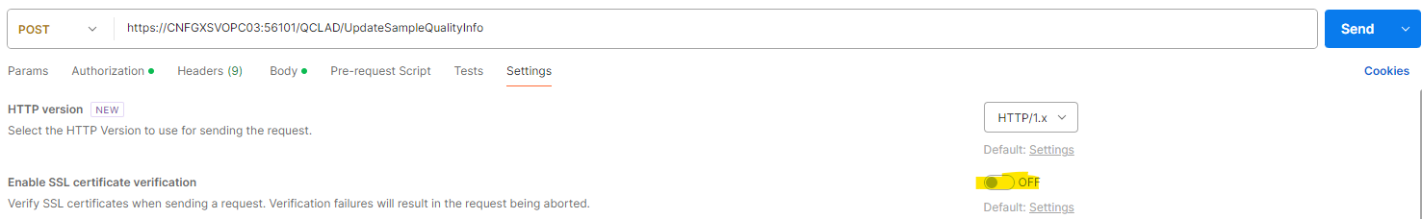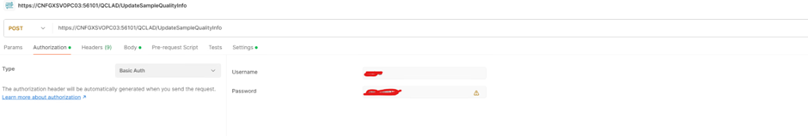

API Specifications
API is required to be developed to successfully integrate QCLAD with DCS. API will need to be developed and exposed to DCS, as explained in the table below.
# | API Name | Description | Hosted On | Type
1 | UpdateSampleQualityInfo | Insert the test results | Henkel Plant Network | Push

UpdateSampleQualityInfo
This API is invoked by QCLAD whenever they are starting the the sample for testing
Web service URL to access DCS System:
https://CNFGXSVOPC03:56101/QCLAD/UpdateSampleQualityInfo
Web service Type: POST
JSON structure to pass the results will follow the same used for MES.
Web service output:
API will return an object as return details.
Return Code Info
Return Code | Description | Action By QCLAD
0001 | Success | No Action
0003 | Duplicate Sample Number | Correct sample number and Resend
0006 | Sample inserted but batch is inactive | No Action
0005 | Invalid JSON | Correct JSON and Resend
Note: In the event of any network failure, QCLAD should resend the data to ensure successful processing.
Response Examples:
{
"MesSampleId": "37158418993",
"Status": "003",
"Message": "Duplicate sample number"
}

{
"MesSampleId": "37158418993",
"Status": "006",
"Message": "Sample inserted but batch is inactive"
}

SAP Interface_Adjustment

Introduction
This document describes the system functionality for the integration of SFG-FG mapping between QCLAD (SampleManager) and SAP as part of Phase B implementation.

Purpose
The purpose of this document is to provide detailed specifications for the sap-QCLAD integration, covering SFG-FG mapping processes, including interface requirements, data mapping, and system logic.

Requirements Background
Bulk IDH is same as material IDH
Bulk batch number is same as SAP batch number
They are differentiating the material as bulk and FG based on valuation class(semi finished goods are mentioned as bulk , finished goods are mentioned as FG).
If user receive a material with valuation class as semi finished good, SAP will send it as bulk IDH and its batch number as bulk batch number.
There can be scenarios where QCLAD may/may not have FG IDH(master data will not be available in Substance. In QCLAD only those materials which have inspection plan are available) but surely we will have bulk IDH. So, we need to do this mapping based on dynamic data received from SAP.

BULK-FG Mapping Process Integration

Interface URL address
QCLAD will expose an API for SAP to send SFG-FG information.

BULK-FG Mapping Info Receiving (SAP to QCLAD)
Example request JSON:
[
{
"srcSystem": "R93",
"apiuid": "INP_API_690B7D1CB73E1FE0A089A97405134345",
"bulkFgPlant": [
{
"plant": "0759",
"fillMatList": [
{
"bulkFgUuid": "BLK_FG_320B7D1CB73E1FD09F86E2AE26BA691C",
"fillingIdh": "2163421",
"fillingBatch": "FILL1234",
"fillingProcessOrder": "0970635",
"bulkMatList": [
{
"bulkIdh": "2163422",
"bulkBatchNumber": "BULK1234",
"bulkProcessNumber": "0970636",
"fillBatchAsgDate": "2025-08-22:10-45-59"
},
{
"bulkIdh": "2163423",
"bulkBatchNumber": "BULK1235",
"bulkProcessNumber": "0970638",
"fillBatchAsgDate": "2025-08-22:10-48-59"
}
]
},
{
"bulkFgUuid": "BLK_FG_320B7D1CB73E1FD09F86E2AE26B7B91C",
"fillingIdh": "2163431",
"fillingBatch": "FILL2234",
"fillingProcessOrder": "0970645",
"bulkMatList": [
{
"bulkIdh": "2163432",
"bulkBatchNumber": "BULK2234",
"bulkProcessNumber": "0970646",
"fillBatchAsgDate": "2025-08-22:11-45-59"
},
{
"bulkIdh": "2163433",
"bulkBatchNumber": "BULK2235",
"bulkProcessNumber": "0970648",
"fillBatchAsgDate": "2025-08-22:11-48-59"
}
]
}
]
}
]
}
]

Example response JSON:
[
{
"srcSystem": "R93",
"apiuid": "INP_API_690B7D1CB73E1FE0A089A97405134345",
"bulkFgPlant": [
{
"plant": "0759",
"fillMatList": [
{
"bulkFgUuid": "BLK_FG_320B7D1CB73E1FD09F86E2AE26BA691C",
"bulkMatList": [
{
"bulkIdh": "2163422",
"bulkBatchNumber": "BULK1234",
"bulkProcessNumber": "0970636",
"ReturnCode": "0001",
"Description": "Success"
},
{
"bulkIdh": "2163423",
"bulkBatchNumber": "BULK1235",
"bulkProcessNumber": "0970638",
"ReturnCode": "0002",
"Description": "No batch found"
}
]
},
{
"bulkFgUuid": "BLK_FG_320B7D1CB73E1FD09F86E2AE26B7B91C",
"fillingIdh": "2163431",
"fillingBatch": "FILL2234",
"fillingProcessOrder": "0970645",
"bulkMatList": [
{
"bulkIdh": "2163432",
"bulkBatchNumber": "BULK2234",
"bulkProcessNumber": "0970646",
"ReturnCode": "0001",
"Description": "Success"
},
{
"bulkIdh": "2163433",
"bulkBatchNumber": "BULK2235",
"bulkProcessNumber": "0970648",
"ReturnCode": "0001",
"Description": "Success"
}
]
}
]
}
]
}
]

Error handling
ReturnCode | Description
0001 | Success
0002 | No Batch Found

Field Mapping
No. | MES Field | Description | QCLAD Field Mapping
1 | PlantCode | Plant code | Plantcode
2 | BulkMaterialList
3 | BulkIdh | material IDH | sample.Hen_IDH
4 | BulkBatchNumber | sap Batch number | sample.BatchName
5 | BulkProcessNumber | sap process Number | sample.hen_sap_process_number
6 | FillingMaterialList
7 | FillingIdh | FillingIdh | sample.Hen_FillingIdh
8 | FillingBatch | FillingBatch | sample.Hen_FillingBatch

System Logic
- SAP sends bulk material data to QCLAD API endpoint
- System verifies:
- Bulk IDH exists in Substance table (mandatory)
- FG IDH availability (optional)
- For valid bulk IDH:
- Creates SFG-FG mapping record
- Returns success response to SAP
- For invalid bulk IDH:
- Logs error in "Pending_Mapping" queue
- Returns error code to SAP

Storage Location in Plant Integration

Business Scenario
To support material adjustment functionality in MES integration, QCLAD requires storage location data from SAP to:
- Validate storage locations during QC adjustment
- Provide dropdown options for users when specifying adjustment materials
- Ensure consistency with SAP inventory management

Interface Requirements
Source Data: Storage locations are provided via SAP Plant Master interface (LGORT field)

Field Additions:

QCLAD  Table | New Field | Source Field | Description
Plant | StorageLocations | LGORT (Plant Master) | Semicolon-delimited list of valid storage locations

Data Flow
Example request JSON:
[
{
"srcSystem": "Q93",
"apiuid": "PLN_API_FE412F97F8EB1FD092F4ECE2B9448FF9",
"parentPlant": [
{
"uuid": "PLN_MAS_FE412F97F8EB1FD092F4ECE2C2C50FF9",
"werks": "S5P9",
"lgort": "0001/0003/0005/0011/8001/9001/9002/9003/9004",
"warehouse": "Y",
"parentplantcode": "0759",
"name1": "WH CN SH BF DG",
"bwkey": "S5P9",
"kunnr": "00PA00S5P9",
"lifnr": "00PAY0S5P9",
"name2": "",
"stras": "No.10359 Puwei Road, Jinshan",
"ort01": "Shanghai",
"land1": "CN",
"vLand1": "People's Republic of China",
"cityc": "",
"adrnr": "0002392416",
"childCrhd": [
{
"arbpl": "QC-LAB",
"verwe": "000",
"planv": "009",
"delInd": " "
},
{
"arbpl": "S5P9-123",
"verwe": "PI0",
"planv": "009",
"delInd": " "
},
{
"arbpl": "S5P9-LAB",
"verwe": "PI0",
"planv": "009",
"delInd": " "
}
]
}
]
}
]

System Logic
      - SAP sends Plant Master data with LGORT field (Example from Plant Master.txt):
"lgort": "0001/0003/0005/0011/8001/9001/9002/9003/9004"
      - QCLAD parses and stores locations in Plant table

Inspection Lot Batch Quantity and Unit Integration

Business Scenario
Enable QCLAD to display and utilize batch quantity/unit from SAP inspection lots for:
- Material adjustment display
- QC decision validation against batch size
- MES interface requirements

Interface Requirements
Source Data: Quantity and Unit information are provided via SAP Inspection Lot interface.
Field Additions:
SAP Field | QCLAD Mapping | Example Value
losmenge | Sample.SAP_BatchQuantity | "300" (from inspection lot.txt)
mengeneinh | Sample.SAP_BatchUnit | "KG"

Data Flow
Example request JSON:
[
{
"inspMatPlnt": [
{
"werks": "0759",
"inspmatdata": [
{
"uuid": "INSP_DATA_518F395F92E71FD09CD2F5F4CF2E60",
"matnr": "000000000002101789",
"prueflos": "14510777",
"art": "89P",
"charg": "0006572802",
"inspLotStatus": "A",
"aufnr": "",
"lichn": "",
"lagortchrg": "",
"vfdat": "",
"lwedt": "",
"qndat": "00000000",
"lifnr": "",
"hsdat": "",
"losmenge": "300", //batch quatity
"mengeneinh": "KG", //batch unit
"activityInsp": [
{
"vornr": "0010",
"inspecChar": [
{
"vorglfnr": "1",
"sollstpumf": 1,
"merknr": "10",
"ersteller": "SINGHA50",
"erstelldat": "2025-08-06",
"satzstatus": "1",
"pmethode": "LOMAPP01",
"verwmerkm": "00000049"
},
{
"vorglfnr": "1",
"sollstpumf": 1,
"merknr": "20",
"ersteller": "SINGHA50",
"erstelldat": "2025-08-06",
"satzstatus": "1",
"pmethode": "LOMPHV02",
"verwmerkm": "00000024"
},
{
"vorglfnr": "1",
"sollstpumf": 1,
"merknr": "30",
"ersteller": "SINGHA50",
"erstelldat": "2025-08-06",
"satzstatus": "1",
"pmethode": "LOMTAK01",
"verwmerkm": "L59"
}
]
}
]
}
]
}
],
"srcSystem": "R93",
"apiuid": "INSP_LOT_API_518F395F92E71FD09CD2F6F823D"
}
]

System Logic
      - Receive inspection lot data from SAP
      - Store batch quantity/unit in sample record
      - Utilize in adjustment

Handling Error Rules

Validation | Error Handling
0001
0002

